UVM Extension Office and Wells Fargo Advisors Move Into 271 N. Main Street in Rutland
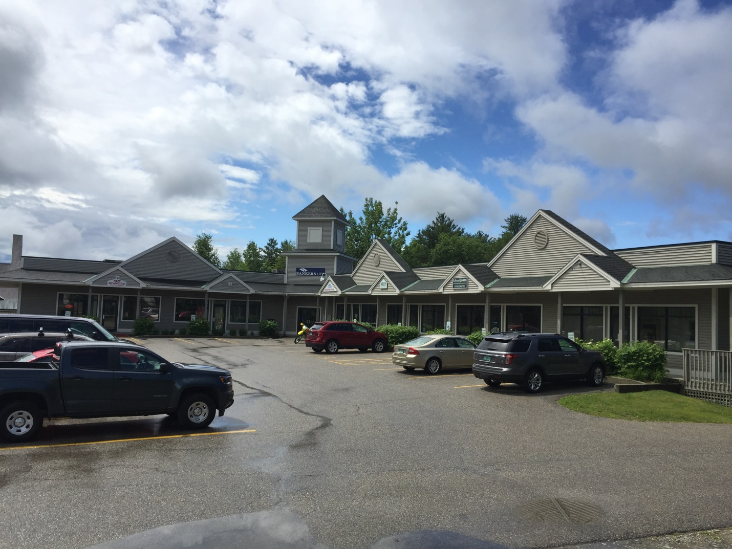

Two recent additions to the complex at 271 N. Main Street in Rutland have added to an already diverse tenant list and brought the buildings to near capacity.
The UVM Extension office recently relocated from its long-time home in the Howe Business Center to Suite 110 on the lower level in the rear of the main building. According to their website, “the new location provides better office space for the employees along with a larger conference room with state-of-the-art technology for meetings, workshops and events.”
Wells Fargo Advisors David Krasner and Robert Kurchena Jr. recently opened an office in Suite 208, providing “a full range of financial products and services, from helping you select individual investments to developing a retirement plan.”
The 33,450SF complex remains for sale, and the price was recently reduced to $1,950,000.

